Basic Concept of Statistics
Statistics:
Like many other sciences Statistics is a developing discipline. It is not static. It has gradually developed during last few decades. In different times, it has been defined in different manners
A.L. Bowley defined statistics as
‘Statistics may be called the science of counting’.
A definition due to W.I. King is

‘Statistics may be defined as the science of collecting, organizing, presenting, analyzing and interpreting numerical data and making valid inferences on the base of the data.’

Types of statistics:

There are two types of statistics
1. Descriptive statistics
2. Inferential statistics.

1. Descriptive Statistics: Descriptive statistics involve graphical and numerical procedures that are used to summarize and process data and to transform data into information.

Example:
A Gallup poll found that 49% of the people in a survey knew the name of the first book of the Bible. The statistic 49 describes the number out of every 100 persons who knew the answer.

2. Inferential Statistics: inferential statistics are used to make inferences about a population from a sample in order to generalize (make assumptions about this wider population) and/or make predictions about the future. Inferential statistics provide the bases for prediction, forecasts and estimates that are used to transform information into knowledge.

Example:
TV networks constantly monitor the popularity of their programs by hiring Nielsen and other organizations to sample the preferences of TV viewer

Some important definitions:

Population: A Population is a Collection of all possible individuals, objects, or measurements of interest.

Sample: A sample is a representative part of the population.

Parameter: A Parameter is a measurable characteristic of a population.

Statistic: A statistic is a measurable characteristic of a sample.
Variable: That changes its characteristics with respect to different aspects. Such as height, weight etc.

Qualitative or Attribute Variable the characteristic being studied is nonnumeric. Example: Gender, Eye color, types of Car etc.

In a Quantitative Variable information is reported numerically. Example: Balance in your account, No of children in a family.

Quantitative variables can be classified as either Discrete or Continuous.

Discrete Variables can only assume certain values and there are usually “gaps” between values.
Example: the number of bedrooms in a house, or the number of hammers sold at the local Home Depot (1, 2, 3, etc).

A Continuous Variable can assume any value within a specified range. Example: the weight of a chop, the height of students in a class.

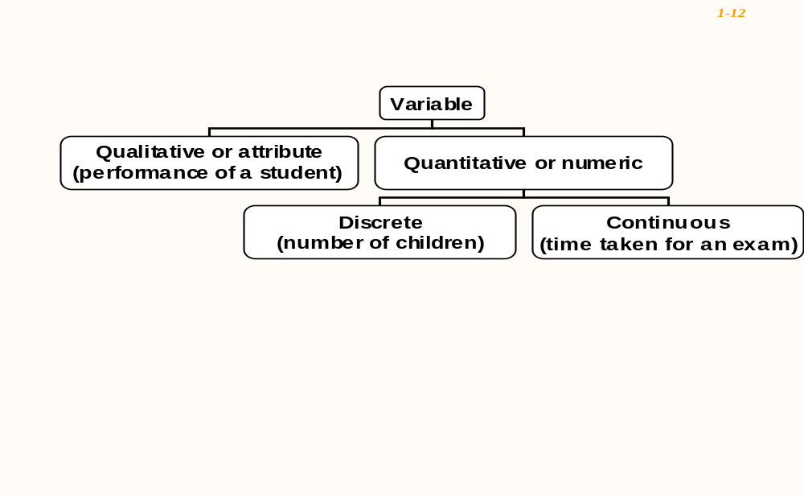

There are four levels of measurements: Nominal, Ordinal, Interval, and Ratio.

Nominal level: Data that is classified into categories and cannot be arranged in any
Particular order. Example: Gender, Eye Color etc.

Ordinal level: involves data arranged in some order, but the differences between data values cannot be determined or are meaningless.
During a taste test of 4 soft drinks, Coca Cola was ranked number 1, Dr. Pepper number 2, Pepsi number 3, and Root Beer number 4.

Interval level: Similar to the ordinal level, with the additional property that meaningful amount of differences between data values can be determined. There is no natural zero point.Example: temparature in Fahrenheit scale.

Ratio level: The intervals level with an inherent zero starting point. Differences and ratios are meaningful for this level of measurement. Ex; Monthly income of a family.

Functions of Statistics:
(i) To present facts in a definite form: Without a statistical study our ideas are likely to be vague, indefinite and hazy, but figures helps as to represent things in their true perspective. For example, the statement that some students out of 1,400 who had appeared, for a certain examination, were declared successful would not give as much information as the one that 300 students out of 400 who took the examination were declared successful.
(ii) To simplify heavy and complex data : It is not easy to treat large numbers and hence they are simplified either by taking a few figures to serve as a representative sample or by taking average to give a bird’s eye view of the large masses. For example, complex data may be simplified by presenting them in the form of a table, graph or diagram, or representing it through an average etc.
(iii) To use it as a technique for making comparisons : The significance of certain figures can be better appreciated when they are compared with others of the same type. The comparison between two different groups is best represented by certain statistical methods, such as average, coefficients, rates, ratios, etc.
(iv) To enlarge individual experience : An individual’s knowledge is limited to what he can observe and see; and that is a very small part of the social organism. His knowledge is extended n various ways by studying certain conclusions and results, the basis of which are numerical investigations. For example, we all have general impression that the cost of living has increased.
But to know to what extent the increase has occurred, and how far the rise in prices has affected different income groups, it would be necessary to ascertain the rise in prices of articles consumed by them.
(v) To provide guidance in the formulation of policies: The purpose of statistics is to enable correct decisions, whether they are taken by a businessman or Government. In fact statistics is a great servant of business in management, governance and development. Sampling methods are employed in industry in tacking the problem of standardization of products. Big business houses maintain a separate department for statistical intelligence, the work of which is to collect, compare and coordinate figures for formulating future policies of the firm regarding production and sales.
(vi) To enable measurement of the magnitude of a phenomenon : But for the development of the statistical science, it would not be possible to estimate the population of a country or to know the quantity of wheat, rice and other agricultural commodities produced in the country during any year.
Importance of Statistics
These days statistical methods are applicable everywhere. There is no field of work in which statistical methods are not applied. According to A L. Bowley, ‘A knowledge of statistics is like a knowledge of foreign languages or of Algebra, it may prove of use at any time under any circumstances”. The importance of the statistical science is increasing in almost all spheres of knowledge, e g., astronomy, biology, meteorology, demography, economics and mathematics. Economic planning without statistics is bound to be baseless.
Statistics serve in administration, and facilitate the work of formulation of new policies. Financial institutions and investors utilize statistical data to summaries the past experience. Statistics are also helpful to an auditor, when he uses sampling techniques or test checking to audit the accounts of his client.
Limitations of Statistics
The scope of the science of statistic is restricted by certain limitations:
1. The use of statistics is limited numerical studies: Statistical methods cannot be applied to study the nature of all type of phenomena. Statistics deal with only such phenomena as are capable of being quantitatively measured and numerically expressed. For, example, the health, poverty and intelligence of a group of individuals, cannot be quantitatively measured, and thus are not suitable subjects for statistical study.
2. Statistical methods deal with population or aggregate of individuals rather than with individuals. When we say that the average height of an Indian is 1 metre 80 centimetres, it shows the height not of an individual but as found by the study of all individuals.
3. Statistical relies on estimates and approximations: Statistical laws are not exact laws like mathematical or chemical laws. They are derived by taking a majority of cases and are not true for every individual. Thus the statistical inferences are uncertain.

